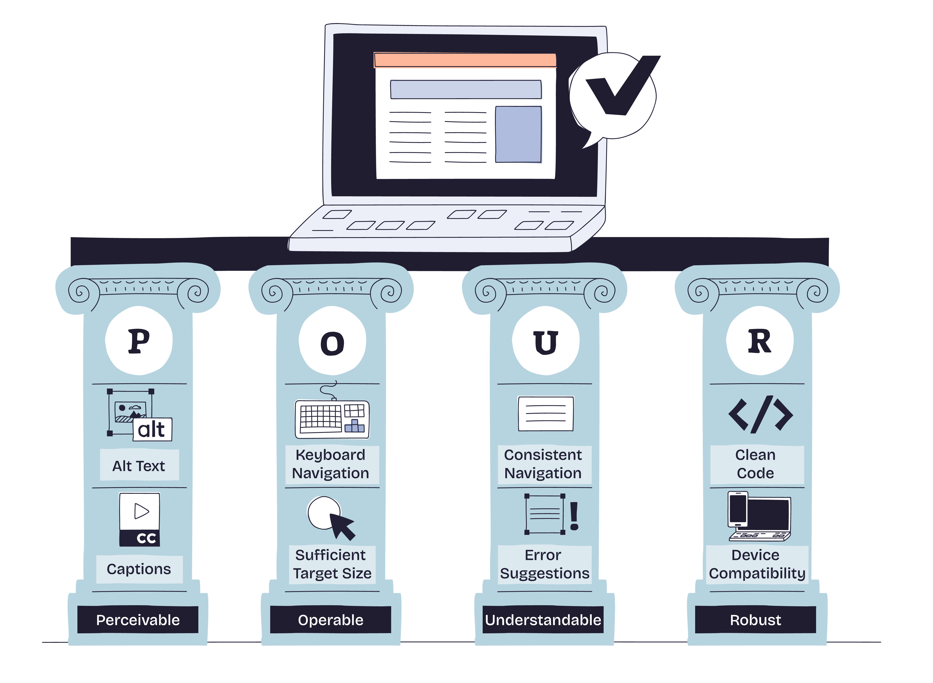

What Is an Accessible Document and Why Is It Important?
Table of Contents
Introduction 3
What Is an Accessible Document? 3
Who Uses Accessible Documents? 3
People With Disabilities 3
People Without Disabilities 3
Why Accessible Documents Are Important 4
Accessibility Supports Equal Access to Information 4
Accessibility Is Required by Law 4
Accessibility Improves Efficiency and Reduces Risk 5
Common Types of Accessible Documents 5
Key Features of an Accessible Document 5
1. Clear Structure and Organization 5
2. Plain Language 6
3. Meaningful Links 6
4. Accessible Lists 6
5. Readable Fonts and Text Layout 7
6. Color and Contrast 7
7. Alternative Text for Images 7
8. Accessible Tables 7
9. Keyboard Accessibility 8
10. Accessible Forms 8
Common Barriers in Inaccessible Documents 8
Accessibility and Title II of the ADA 9
Accessibility Is a Shared Operational Responsibility 9
Getting Started with Accessible Documents 9
Conclusion 10

Introduction
Accessible documents are written and formatted so that everyone—including people with disabilities—can read, understand, and use the information. Accessibility makes documents easier to navigate, clearer to read, and more usable across different devices and assistive technologies. Creating accessible documents is not just a technical step; it is part of making information available to all.

What Is an Accessible Document?
An accessible document is a document that can be accessed, understood, and navigated by as many people as possible, regardless of disability, technology, or environment.
Accessible documents are designed to:
- Work with screen readers and assistive technologies
- Support keyboard-only navigation
- Function across devices such as desktops, tablets, and mobile phones
- Remain usable in a variety of conditions, such as low bandwidth or poor lighting
Accessibility is not a separate or special version of a document. It is about building usability and compatibility into the original document from the start.

Who Uses Accessible Documents?
Accessible documents are used by a wide range of people in everyday situations.

People With Disabilities
Accessible documents support people with:
- Visual disabilities (blindness, low vision, color blindness)
- Auditory disabilities (deafness, hard of hearing)
- Motor disabilities (limited hand use, tremors, paralysis)
- Cognitive disabilities (learning disabilities, memory, attention, or processing challenges)

People Without Disabilities
Accessible documents are also used by:
- People using phones, tablets, or different operating systems
- Older adults experiencing changes in vision, hearing, or dexterity
- People with slow internet connections or limited bandwidth
- People with temporary limitations, such as a broken arm or eye strain
- People in situations where using a mouse, audio, or visual content is difficult
Documents that are accessible are easier for everyone to use.

Why Accessible Documents Are Important

Accessibility Supports Equal Access to Information
Access to information is essential for participating in government programs, services, and activities. When documents are difficult or impossible to use, people may be unable to complete forms, understand requirements, or receive services.
Accessible documents help ensure that information is available in a usable format for the public.

Accessibility Is Required by Law
Under Title II of the Americans with Disabilities Act (ADA), state and local governments are required to provide equal access to:
- Programs
- Services
- Activities
- Information and communications
This requirement applies to digital documents, including:
- PDFs
- Word documents
- PowerPoint presentations
- Forms
- Online publications
Failure to provide accessible documents may result in:
- Civil rights complaints
- Federal enforcement actions
- Legal liability
- Rework, delays, and increased costs
- Loss of trust

Accessibility Improves Efficiency and Reduces Risk
Accessible documents:
- Reduce the need for individual accommodations
- Decrease follow-up questions and corrections
- Improve accuracy when forms are completed
- Lower the risk of complaints and retroactive fixes
Building accessibility into documents early is more efficient than correcting problems later.

Common Types of Accessible Documents
Accessible documents include:
- Word documents (.docx)
- PDF files
- PowerPoint presentations (.pptx)
- Excel spreadsheets (.xlsx)
- Online forms and applications
- Reports, manuals, and guidance documents
The file type matters less than how the document is structured and formatted.

Key Features of an Accessible Document
- Clear Structure and Organization
Accessible documents use proper structure so users can understand how information is organized.
This includes:
- Logical heading levels
- Short, clearly labeled sections
- Consistent formatting
Example of Proper Heading Structure
- Heading 1: Document Title
- Heading 2: Main Section
- Heading 3: Subsection
Text should not be made into headings by using size, color, or bold alone.
- Plain Language
Plain language helps people:
- Find information quickly
- Understand instructions
- Complete tasks accurately
Plain language includes:
- Short sentences
- Common words
- Active voice
- Clear instructions
Plain language improves comprehension for all readers.
- Meaningful Links
Links should describe where they go or what they do.
Poor Example
- Click here
Better Example
- Read guidance on ADA Title II digital accessibility
Helpful resources:
- ADA.gov: https://www.ada.gov/
- Web Content Accessibility Guidelines (WCAG): https://www.w3.org/WAI/standards-guidelines/wcag/
- Accessible Lists
Lists should be created using built-in list tools rather than manual spacing.
Accessible lists:
- Help screen readers convey relationships
- Make information easier to scan
- Improve consistency
- Readable Fonts and Text Layout
Readable text includes:
- Simple, commonly used fonts
- Adequate font size (generally 11–12 pt or larger)
- Left-aligned paragraphs
- Sufficient spacing between lines and sections
Avoid dense blocks of text and decorative fonts.
- Color and Contrast
Color should not be the only way information is communicated.
Accessible color use includes:
- Sufficient contrast between text and background
- Text labels in addition to color cues
Example:
- Instead of relying on red text alone, label required fields with text
- Alternative Text for Images
Images must include alternative text (alt text) that conveys the purpose of the image.
Alt text should:
- Be concise and accurate
- Describe meaning, not appearance alone
- Exclude phrases like “image of” or “picture of”
Decorative images should be marked as decorative.
- Accessible Tables
Tables should be used only to present data.
Accessible tables include:
- Clearly identified column headers
- Simple structure
- Logical reading order
Example Table: Document Accessibility Practices
Recommended Practice | Avoid
Use header rows | Use tables for layout
Keep tables simple | Merge cells unnecessarily
Provide context | Leave cells empty
- Keyboard Accessibility
Documents must be usable without a mouse.
Users should be able to:
- Navigate links and fields using a keyboard
- Move through content in a logical order
This supports users who rely on keyboard navigation.
- Accessible Forms
Accessible forms include:
- Clear labels for every field
- Instructions that explain what is required
- Logical tab order
- Error messages that explain how to correct mistakes
Forms should not rely on color, position, or placeholders alone.

Common Barriers in Inaccessible Documents
Common issues include:
- Missing or incorrect headings
- Scanned PDFs without readable text
- Images of text
- Poor color contrast
- Unlabeled form fields
- Incorrect reading order
These barriers can prevent people from completing tasks independently.

Accessibility and Title II of the ADA
Title II of the ADA requires public entities to ensure that digital content is accessible.
Key expectations include:
- Proactive accessibility
- Consistent implementation
- Ongoing review of documents and workflows
Accessibility should be addressed during document creation, not only after complaints are received.

Accessibility Is a Shared Operational Responsibility
Creating accessible documents is not limited to technical staff.
It involves:
- Content authors
- Program staff
- Communications teams
- Managers and leadership
Accessibility is most effective when it is built into standard processes.

Getting Started with Accessible Documents
Practical first steps:
- Use built-in heading and list styles
- Write clearly and directly
- Add alt text to images
- Check color contrast
- Use accessibility checkers
Common tools:
- Microsoft Word Accessibility Checker
- Adobe Acrobat Accessibility Checker
- Built-in accessibility tools in PowerPoint and Excel

Conclusion
Accessible documents support equal access to information, improve usability, and reduce legal and operational risk.
They help agencies:
- Meet legal requirements
- Communicate more effectively
- Provide reliable access to information and services
Accessibility is not an extra step—it is good design, clear communication, and responsible document management.

